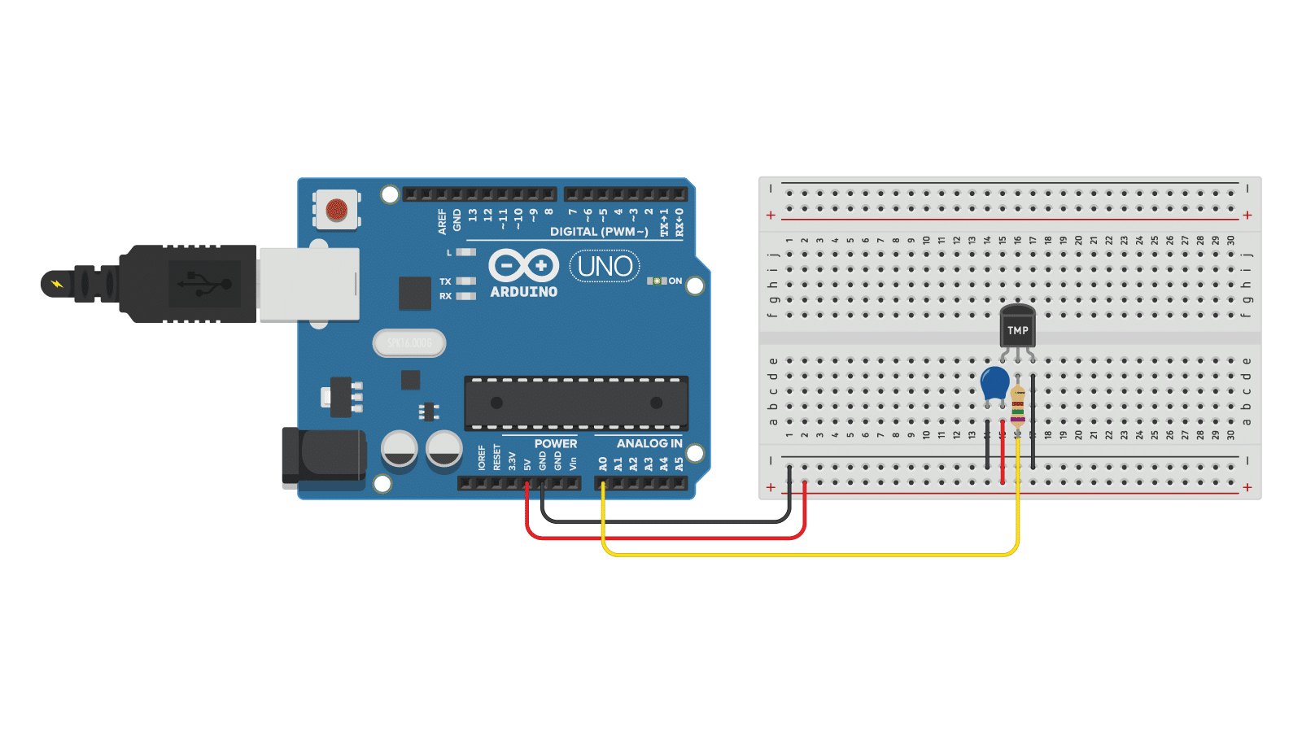

int sensorPin = A0; // TMP36 middle pin connected to A0
float voltage, temperatureC, temperatureF;

void setup() {
Serial.begin(9600);
}

void loop() {
int sensorValue = analogRead(sensorPin);

// Convert ADC value to voltage (5V Arduino)
voltage = sensorValue * (5.0 / 1023.0);

// TMP36 gives 750 mV at 25°C, and scale is 10 mV per °C
temperatureC = (voltage - 0.5) * 100.0;

// Convert °C to °F
temperatureF = (temperatureC * 9.0 / 5.0) + 32.0;

Serial.print("Temperature: ");
Serial.print(temperatureC);
Serial.println(" °C");

delay(1000);
}

